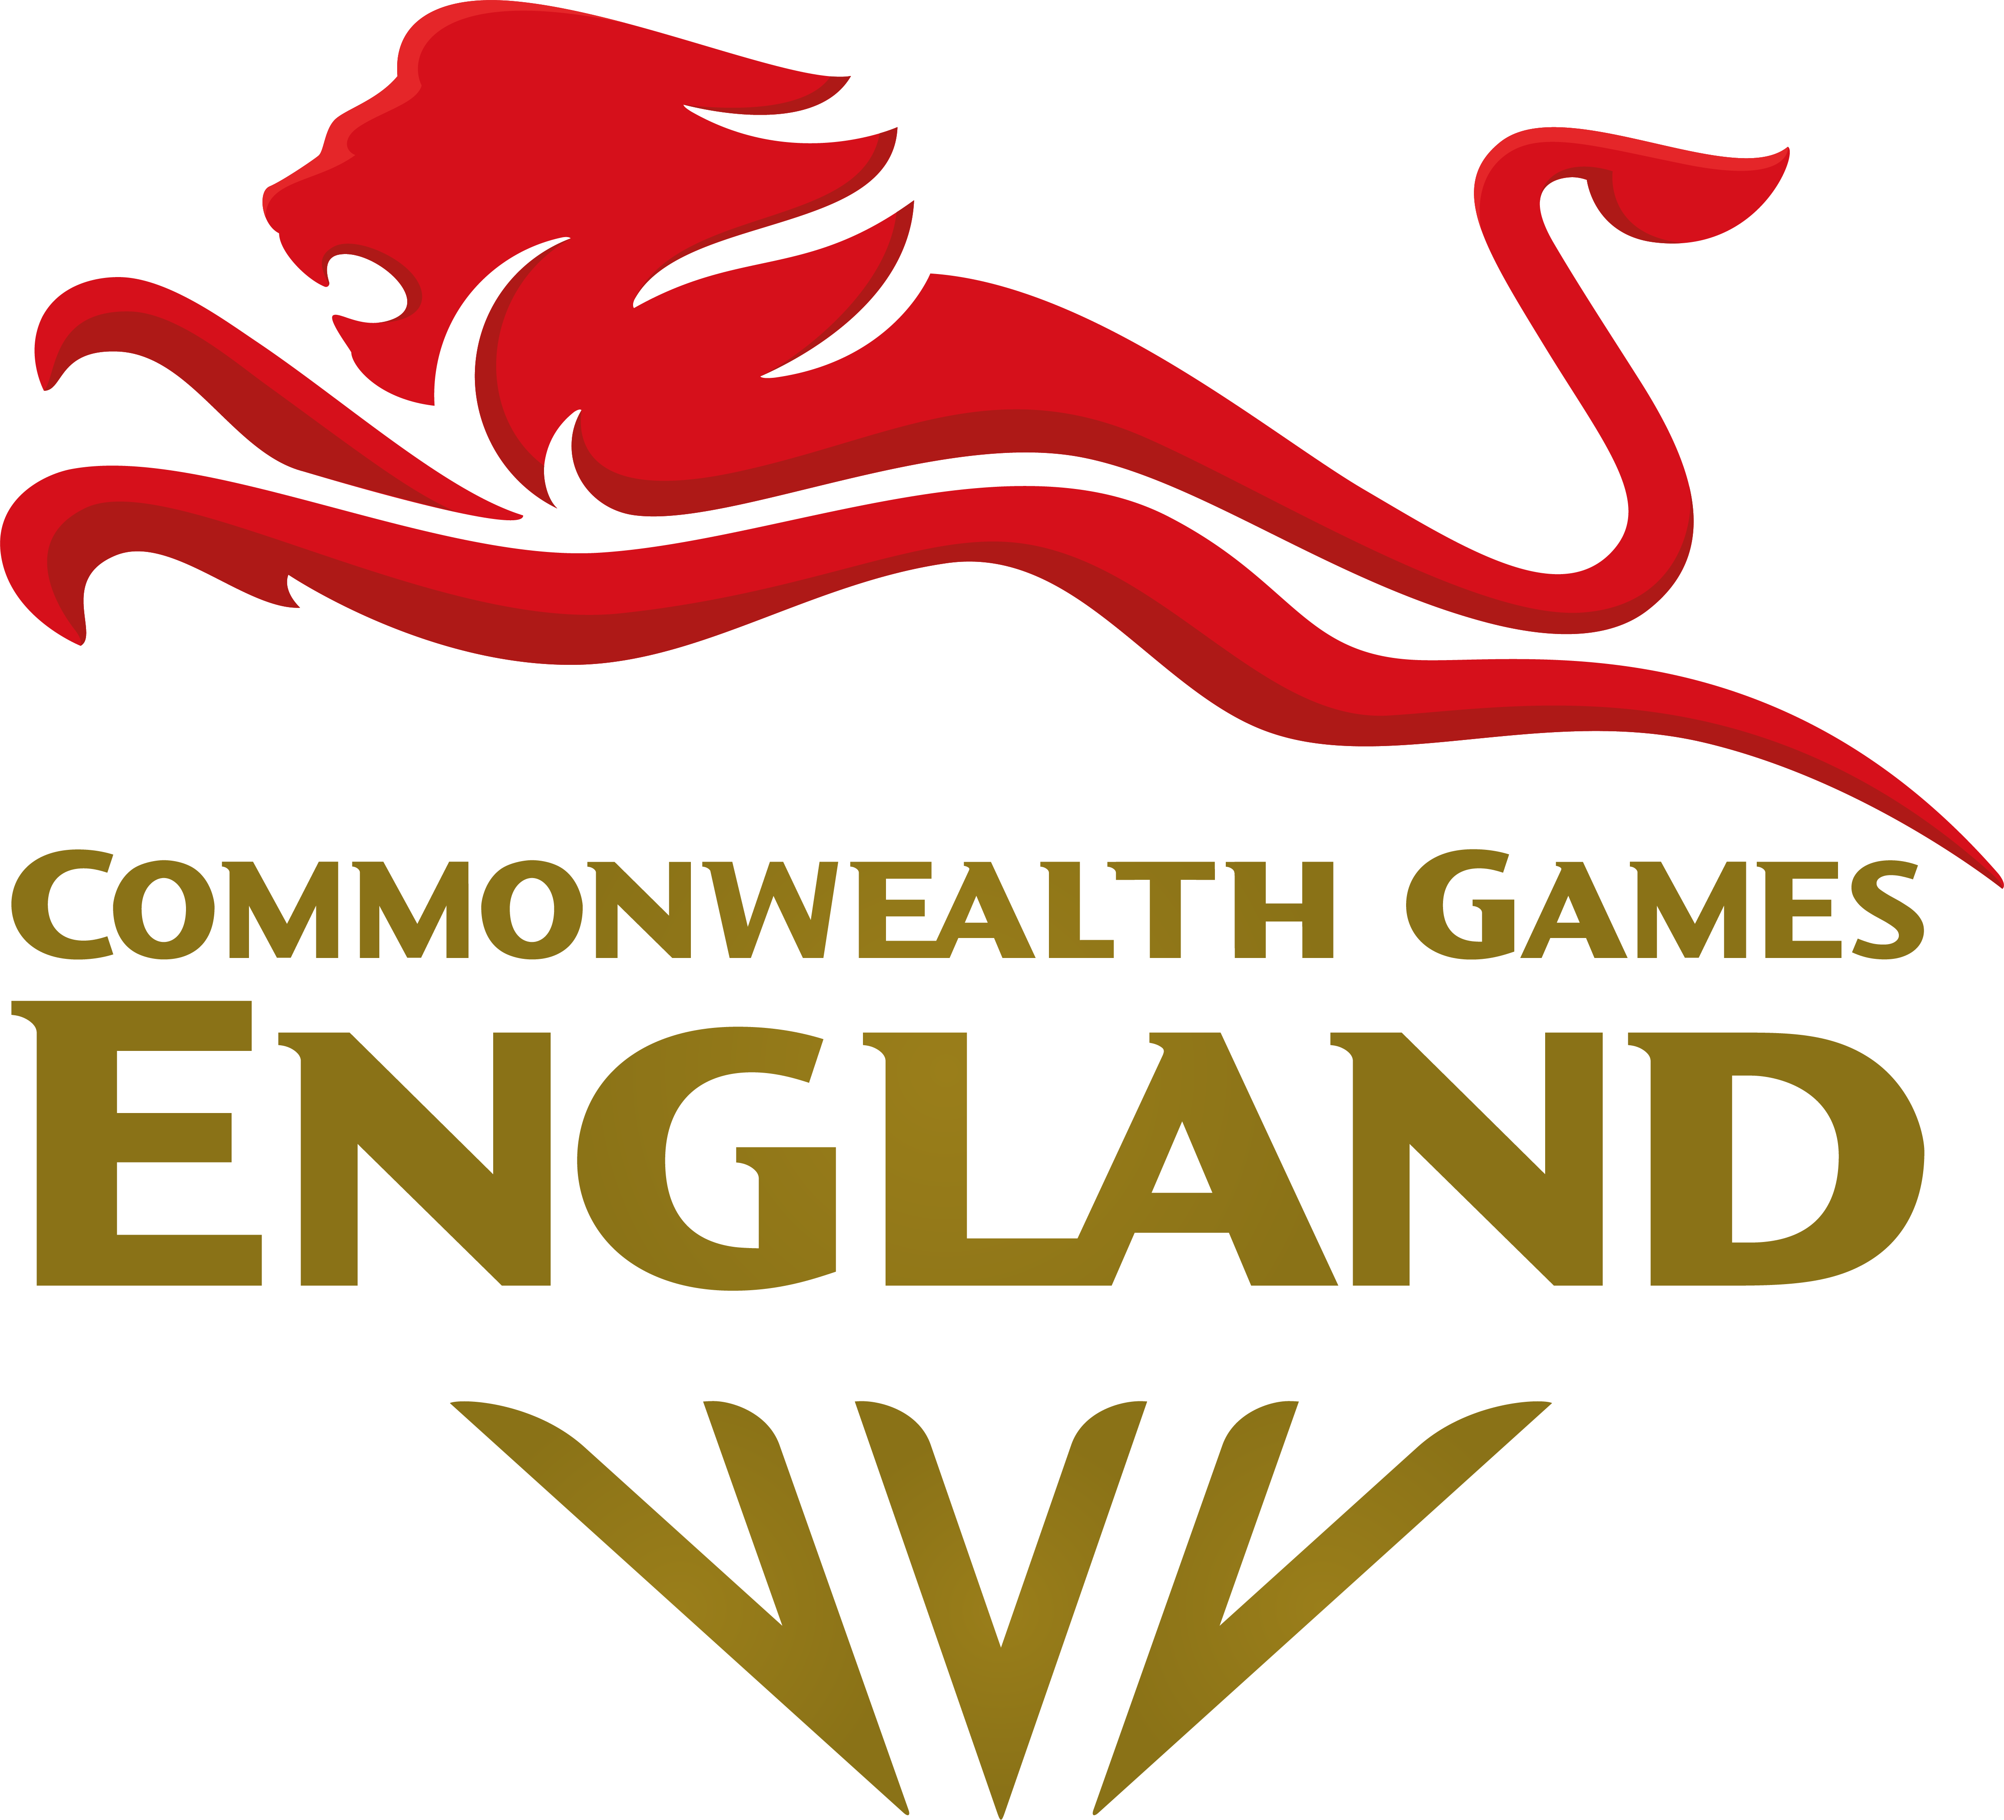

EQUALITY DIVERSITY AND INCLUSION PROGRESS REPORT (2021)
December, 2021

Foreword

President, Denise Lewis, CEO, Paul Blanchard, and the entire Board and executive staff of CGE.

In October 2017, alongside many other National Governing Bodies, Commonwealth Games England launched its five-year Diversity Plan. The Plan was launched during the run up to the Gold Coast 2018 Games, and culminates with a home Games in Birmingham this summer.

We are very proud of the progress we have made with the plan. Since our last EDI annual report (March 2020), we have made a number of important and positive advances, including:

- the creation of an executive led EDI working group;
- we have signed up to the Sporting Equals Charter, giving a commitment to increase ethnic diversity at all levels;
- we have engaged Equality and Diversity UK to deliver educational sessions to our executive team and Board;
- we have also engaged Equality and Diversity UK to support us in the upgrade of our EDI action plan
The culture which our Team England staff and athletes will demonstrate at the Birmingham 2022 Games has been built under the leadership of our Chief Executive Paul Blanchard, our Chef de Mission, Mark England OBE, and our team leaders. The team’s culture is based around the word PRIDE: Performance, Respect, Inspiration, Diversity and Excellence. We believe that both our team and the “team behind the team”, representing England at the Birmingham 2022 Games will be the most diverse English team to represent this country in a Commonwealth Games.

The Board and the executive have undertaken unconscious bias training. We are delighted to celebrate a diverse and inclusive Board with a 50:50 gender split and 25% ethnic minority representation.

We have worked hard to communicate our commitment to diversity both internally and externally. We value our strong relationships with our member National Governing Bodies and will increasingly use this platform to reinforce our commitment to diversity. We are particularly pleased to see more diverse talent progressing at every level – from athletes and coaches to our volunteers, staff, and Board.

We ran our most extensive recruitment process for our Birmingham Games volunteers, in 2021. We reached a wider pool of people by extending the advertisement onto numerous platforms, hosting a volunteer webinar and building a new volunteer webpage. The overall process contributed to increasing the number of applications we had in the previous cycle by 91%. Not only did this demonstrate our commitment to our equality, diversity and inclusion objectives, but it also generated applications from those with more diverse backgrounds.

In Birmingham there will be more medals to be won by women than men – a first in major multi-sport event history. The Birmingham Games will also host the biggest integrated para sport programme in Commonwealth Games history, across eight sports: athletics, swimming, para powerlifting, lawn bowls, table tennis, cycling, wheelchair basketball and triathlon.

This report evaluates our performance across the goals we set ourselves in and since March 2020. We have refined our targets from the original 2017 strategy document to reflect the current Birmingham 2022 Games cycle and beyond.

Everyone at Commonwealth Games England remains completely committed to diversity and inclusion in all areas of our work.

Contents

Recruitment 4
Engagement 7
Progressing talent from within 9

Recruitment

How the organisation will attract an increasingly diverse range of candidates.

Objective: Embed good diversity and inclusion practice into our recruitment activities and decision-making processes.
Short Term Targets | Owner | Achieved? | Detail
- Target a diverse range of candidates for the Non-Executive Director vacancies through a combination of working in partnership with diverse organisation and reaching out to a diverse range media. | Ian Metcalfe, Tom Harlow |  | The current round of NED recruitment has been undertaken by Odgers Berndston on behalf of the Nominations Committee, who ensured a fair and open process, with the roles advertised on a range of external platforms. Our current Board has a 6:6 male: female ratio (March 2022) with 3 members from the BAME community and 1 para-athlete.  Succession planning is in place for post B2022 when many NED’s including the Chair, will step down.  Board Profiles
- Advertise all CGE vacancies publicly and openly through diverse channels to audiences currently underrepresented. | Tom Harlow |  | We have continued to advertise on a wide range of platforms and channels for our Games specific roles.  The platforms include UK Sport, Sporting Equals, Diversifying UK, Evenbreak, Careers with Disabilities and our social channels. We have continued our diversity survey as part of this process.
- Rebuild Jobs/Volunteering webpage to ensure diverse images and information whilst at the same time embedding engaging and informative content that demonstrates our commitment to our equality, diversity, and inclusion objectives. | Carys Edwards, Harriet Smith |  | The volunteer webpage was built in addition to the job’s application page.  An overview of the volunteer experience, access to job specific details and pre and Games time commitments were included.  Three video interviews with former volunteers were included on the webpage to provide insight into the experience and encourage more people to apply.  All job adverts also included our commitment to EDI to encourage new applicants.
- Review the recruitment process and EDI policy to ensure that conscious/unconscious biases are removed, and our practices are in line with good EDI practices. | EDI Working Group | Ongoing | Staff training and awareness took place with Diversity and Inclusion UK in Feb 2021, prior to the Volunteer recruitment drive. Further training has since been provided for new starters who have joined since Feb 2021.  Following this education, our recruitment process including advertising, information sharing, shortlisting, and interviewing has been refined to improve the reach of applications.
- Design/deliver a volunteer information and Q&A session to help remove barriers that currently exclude applicants. | Harriet Smith | April | The webinar took place on 23rd April 2021 (St Georges Day). The objectives were to:  - Provide information to engage and promote new applications.  - Breakdown barriers around financial commitments, accessibility at the Games and promote our commitment to EDI.  - Have a live audience so we could answer questions throughout the presentation. The recording was also available online throughout the process.  This was a successful pilot for future recruitment campaigns and was delivered in partnership with Sport England.
Medium and long term targets | Owner | Achieved? | Detail
- Collect Equality data, analyse it and use it to plan/ report across new applications. | Tom Harlow, Harriet Smith | Ongoing | We’ve continued voluntary surveys for job applicants that ask questions across the protected groups.  The data we gathered from the survey allowed us to identify where we were under indexing and focus on targeting specific platforms.
- Build EDI objectives across all departments everyday practice and report on progress annually. | Harriet Smith | September, Ongoing HS | Each of the objectives will be reported on by department heads on an annual basis as part of this report to ensure the exec engagement.  Sport – Treat all sports, athletes, and officials on the same level, awarding servicing and resources equally.  Operations – Create an inclusive environment to ensure that all athletes and team members go on the same journey from selection. Including kit, transport, as well as pre and Games venue accessibility.  Communications – Captured within engagement objectives.  Project Management – Maintain quarterly planning days to ensure cross departmental communication and critical project overview is maintained across all levels of management.  Stakeholder Programme – Effective communication across all stakeholders and developing a VIP programme that is inclusive and accessible.  Organisational – Appropriate team training, provide up to date ED&I language resources, continue to review and bring policies to life to ensure inclusion across the team.
- Repeat the Board skills audit on an annual basis to ensure that it has the diversity of skills, lived experiences, understanding and knowledge required to deliver on EDI. | Ian Metcalfe | Ongoing | An independent assessment takes place at least every 4 years (last done in 2019).

Engagement

Ensuring that your organisation’s commitment to diversity is communicated through internal practices and externally

Objective: Ensure our commitment to diversity is at the heart of our communications

Short term targets | Owner | Achieved? | Detail
- Create strong messaging about how we commit to and deliver on EDI in the lead up to the Games to celebrate the success and diversity of Team England. | Carys Edwards |  | Work with Diversity and Inclusion UK to uplift our public facing action plan and internal equality policy to ensure we are meeting best practice. We will continue to prioritise EDI in all forms throughout the lead up, during and post Games.  Continue to use our media platforms to promote equality messages within sport and from the Commonwealth Games Federation.  Additionally, the Team England website now includes an accessibility menu to enable users to change, keyboard navigation, transitions, contrast, font size, font family, cursor colour and zoom.  Added a comments box on our website that allows the public to feedback on our diversity strategy and action plan.
Medium and long term targets

- Build on the Team culture and identity through the development of a Team England narrative that brings the PRIDE values to life. | Paul Blanchard, Francesca Carter- Kelly | Ongoing | Ongoing planning and research with internationally renowned Performance Coach, Owen Eastwood to create the Team culture and identity and bring this to life across all Team England athletes, team officials and volunteers.  Leadership Workshop took place in Q4 2021. PRIDE messaging to be developed for Birmingham 2022.
- Ensure the diverse nature of the Games and its athletes are reinforced through CGE engagement with NGB’s, partners, sponsors, stakeholders, and the media. | Paul Blanchard | Ongoing | Key stakeholder engagement comes through our newsletters, workshops and events hosted throughout the year. We prioritise diverse representation of presenters as well as the content.  Since March 2020, we have set up three advisory groups that promote EDI through their membership and objectives; a Team Leader Advisory Group (set up in Q2 2020) and Athlete Advisory Group (set up Q3 2020) as well as an additional Athlete Panel (set up Q3 2020) that was set up to review the kit design and development.  Additionally, we have formal forums including our bi-annual NGB CEO Group meetings, AGM, Team Leader Workshops and our new NGB Communications Group (set up Q1 2021).
- Ensure all CGE media and social engagement continue to reinforce robust respect for diversity messages. | Carys Edwards | Ongoing | CGE digital strategy and tone of voice reflects a commitment to ED&I throughout. Digital campaigns, for example Heroes through History and Generation 22, showcases the diversity of Team England.  Website | Facebook | Instagram | Twitter | LinkedIn

Progressing talent from within
A focus on developing a strong internal pipeline of diverse talent to populate decision making and other structures.

Objective: Utilise the Board’s Committees to welcome and develop diverse talent. Utilise home nation talent development opportunities as well as secondment openings at other multi-sport events.

Medium and long term targets | Owner | Achieved | Detail
Create opportunities to encourage a diverse range of board members onto the four Board Committees. | Ian Metcalfe | Ongoing | New Board members John Steele and Diane Modahl have been appointed (March 2021) following an open and transparent process, where diverse candidates were encouraged to apply.
Provide Board readiness mentoring for new Board members and co-opted Sub-Committee members as required. | Ian Metcalfe, Chris Conway | Ongoing | The board induction is now structured to include a full induction, buddy system and is tailored to the individual.
Ensure that staff, managers, and board members at all levels are trained in EDI. Conduct staff EDI experience surveys annually and analyse the findings and use to review the EDI action plan. | EDI Working Group | Ongoing | The exec team received their first unconscious bias course with Diversity and Inclusion UK in Feb 2021. This training was provided pre volunteer recruitment and learnings will be championed by the EDI working group. A key outcome of this session was the language guide, something that has become a key resource for the team in the last 12 months. Further training has since been provided for new starters who have joined since Feb 2021.  Additionally, we are looking to invest in short courses/information tools for the Board as well as for Team Leaders. We will continue to work with Diversity and Inclusion UK as well as Sporting Equals to find the right material.
Continue to fairly provide professional development opportunities through secondment openings with the BOA, BPA, School Games and BUCS. | Paul Blanchard | Ongoing | CGE has supported both the British Olympic Association and British Paralympic Association during the Tokyo 2020 campaign. 18 team members from CGE have played significant roles in helping deliver both the Olympic and Paralympic Games.  The experiences provided exposure to the multi-sport, high pressure environment - supporting upskilling in many areas of operational delivery.  Overall, the involvement spanned from Jan 2021 – Sept 2021 and covered several areas of delivery:  - BOA & BPA Kit / Kitting Out  - BOA & BPA Operations and Village  - BOA & BPA Arrivals and Departures  - BOA Operations and Prep Camp  - BOA Comms / Digital  - BOA VIP / Stakeholder Programme  In addition to the Olympics and Paralympics, members of the team were also offered event experience at the School Games in various roles.  Separate to event experience, all members of staff were nominated for a UK Sport coaching and upskilling course.  All staff are also provided access to online training courses via, Improve.
Deliver the Team England Futures and Sir John Hanson Scholarship programmes with legacy as a priority | Francesca Carter-Kelly | Ongoing | Commonwealth Games England in partnership with SportsAid and Sport England have developed the framework for the Team England Futures programme. The programme will provide young athletes and aspiring team support staff from all backgrounds, including from the programme, Backing the Best - with unique experiences and insights into a multi-sport, major Games environment, to better prepare them for delivering medal winning performances as either Team England, Team GB or Paralympics GB debutants at future Games  Commonwealth Games England have developed and begun delivery for the Sir John Hanson Scholarship programme. With a home Games in Birmingham in 2022, each athlete striving to compete at the Games will receive access to funding, to support them in achieving their sporting goals. Athletes include Abi Burton – Rugby 7s, Kieran Rollings – Para Lawn Bowls, Lucy Turmel - Squash, Tom Jarvis – Table Tennis and Daniel Dixon – Triathlon.

